Infonique Voice Recognition

|  |  |  |
| --- | --- | --- |
| Prepared by | Date | Version |
| Bing Ran | 03/20/2025 | 1.0 |

# 1 Abstract

This document details the implementation of a voice recognition system using the ESP32, covering both hardware and software aspects. The system is designed to recognize voice commands, process them, and respond with spoken feedback using pre-recorded audio files. The hardware includes an ESP32 Dev module, a VC-02 voice recognition module, an I2S audio output system, and an OLED display for visual feedback. The software integrates voice detection, serial communication, and audio playback . This document provides an in-depth exploration of system design, firmware development, and practical considerations, offering a comprehensive guide for developers interested in embedded voice recognition applications.

# Document History

|  |  |  |  |
| --- | --- | --- | --- |
| **Date** | **Rev** | **Modifier** | **Changes** |
| **20-March-2025** | 1.0 | Bing Ran | First Draft |
|  |  |  |  |
|  |  |  |  |
|  |  |  |  |
|  |  |  |  |

# Contents

1 Abstract 2

Document History 2

Contents 3

Table of Figures 4

Table of table 4

1 Introduction 5

1.1 Overview of Sound Recognition Technology 5

1.2 Importance of Embedded Sound Recognition 5

1.3 Objectives of This Project 5

2. Hardware 6

2.1 ESP32 – Microcontroller for Processing 6

2.2 VC-02 Voice Recognition Module – Recognizing Voice Commands 7

2.3 I2S Audio Output (MAX98357A + Speaker) – Playing Responses 8

2.4 SSD1306 OLED Display – Visual Feedback 9

2.5 SHT31 Temperature & Humidity Sensor – Sensor Data Acquisition 10

3 Setting up Development Environment 11

3.1 Block Diagram 11

3.2 Schematic of the infonique voice recognition 12

3.3 Pinout connection 13

3.4 Hardware compoenents 13

3.3 Development Environment 14

Step 1 : Install Arduino IDE to program the ESP32. 14

Step 3 : Install Required Libaries 14

Step4: Configure LittleFS for WAV file storage. 14

Step 5: Connecting the hardware 15

Step 6 Run your firt voice command. 15

# Table of Figures

Figure 1: ESP32 Dev Module 6

Figure 2: VC-02 Module 7

Figure 3: MAX9875A 8

Figure 4: SSD1306 OLED Display 9

Figure 5: SHT31 10

# Table of table

Table 1: ESP32 Pin Connection 14

Table 2: Hardware Component 14

# 1 Introduction

## **1.1 Overview of Sound Recognition Technology**

Voice recognition technology allows electronic devices to interpret and respond to audio signals, enabling voice commands, environmental sound detection, and real-time interaction. This technology is widely used in applications such as **voice assistants (e.g., Alexa, Google Assistant), security systems, and accessibility tools** for individuals with disabilities.

At its core, **voice** recognition involves **capturing audio signals, processing them to extract features, and matching them to predefined patterns**. With the advancement of machine learning and edge computing, microcontrollers like the **ESP32** can now perform sound recognition efficiently without requiring cloud-based processing.

## **1.2 Importance of Embedded Sound Recognition**

Embedded **voice** recognition plays a crucial role in creating smart and interactive systems. Unlike cloud-based solutions, **embedded sound recognition processes audio locally on the device**, offering advantages such as:

* **Faster response time** (no internet dependency)
* **Better privacy and security** (audio data is not sent to external servers)
* **Lower power consumption** (suitable for battery-powered devices)

For students, learning **embedded voice recognition** provides valuable insights into **digital signal processing (DSP), machine learning on microcontrollers, and real-world embedded system development**.

### **1.3 Objectives of This Project**

The goal of this project is to provide **students with hands-on experience** in implementing a **voice recognition system** using the **ESP32 microcontroller**. This system will:

1. **Recognize voice commands** using the **VC-02 voice module**
2. **Retrieve and announce temperature & humidity** data from an **SHT31 sensor**
3. **Provide audio responses** via **I2S speaker output**
4. **Display real-time readings** on an **SSD1306 OLED screen**
5. **Use LittleFS for storing and playing pre-recorded audio files**

By completing this project, students will learn about **microcontroller programming, interfacing with hardware components, and implementing embedded voice recognition in practical applications**.

# **2. Hardware**

The selection of hardware components plays a crucial role in ensuring smooth operation and performance of the embedded **voice** recognition system. Each component has been chosen to provide efficient processing, reliable voice recognition, clear audio output, real-time display feedback, and accurate environmental sensing.

## **2.1 ESP32 – Microcontroller for Processing**

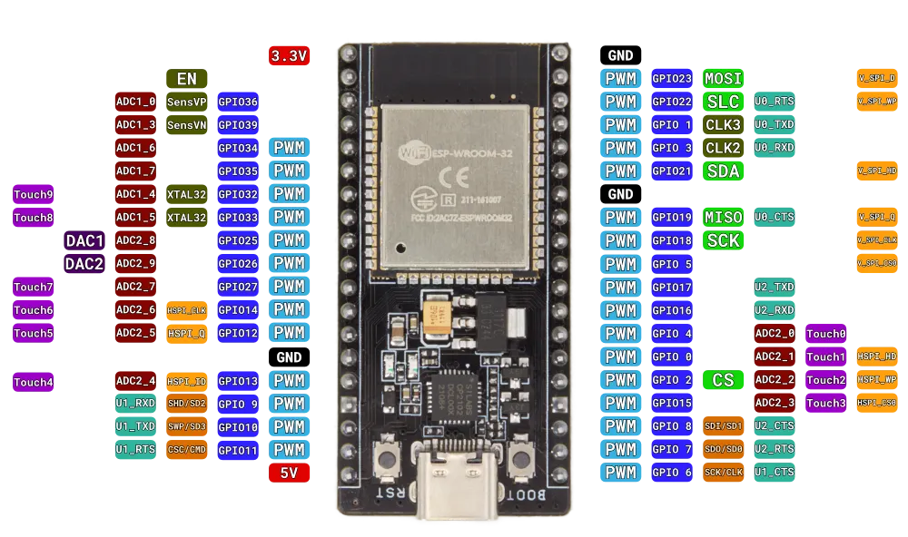Figure 1: ESP32 Dev Module

The **ESP32** is the core processing unit of this project, responsible for handling all data processing, communication, and control operations. It is chosen due to its:

* **Dual-core processor** for handling multiple tasks efficiently
* **Wi-Fi & Bluetooth capabilities** (though not used in this project, they allow future expansion)
* **Integrated I2S, I2C, and UART interfaces** for seamless connection with peripherals
* **Low-power operation** suitable for battery-powered applications

The ESP32 manages the **voice recognition module (VC-02)**, processes **temperature and humidity sensor readings (SHT31)**, controls the **OLED display (SSD1306)**, and plays **audio responses using the MAX98357A I2S audio amplifier**.

## **2.2 VC-02 Voice Recognition Module – Recognizing Voice Commands**

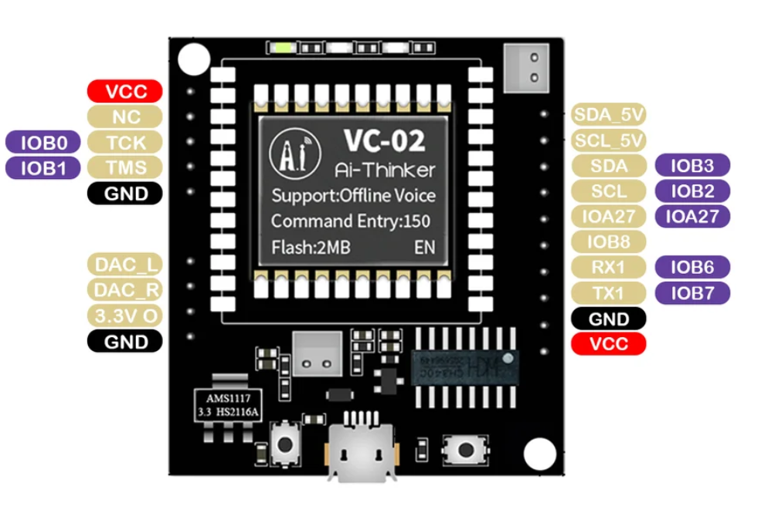Figure 2: VC-02 Module

The **VC-02** module is a compact, pre-trained voice recognition module capable of recognizing custom voice commands. It is selected due to:

* **Built-in offline voice recognition** (no need for internet access)
* **Customizable wake words & commands**
* **UART interface for easy communication with ESP32**
* **Low power consumption**

**Function in the Project**

* Detects specific voice commands like "Hi Pudding", "Humidity", “Temperature” and "Siren"
* Sends recognized command data to ESP32 via **UART**

## **2.3 I2S Audio Output (MAX98357A + Speaker) – Playing Responses**

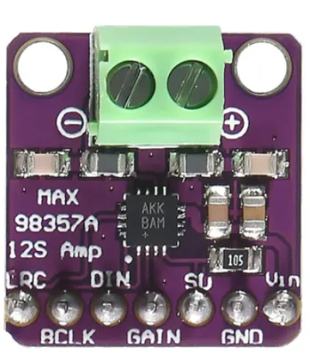Figure 3: MAX9875A

The **MAX98357A** is a **digital-to-analog converter (DAC) and audio amplifier** that converts digital I2S signals into analog audio output, which is played through a **connected speaker**.

**Reasons for Choosing MAX98357A**

* **I2S support** for high-quality audio playback
* **Built-in amplifier** eliminates the need for additional circuitry
* **Compact and low-power** design

**Function in the Project**

* Receives **pre-recorded WAV audio files** stored in ESP32's **LittleFS** storage
* Converts digital audio signals into analog signals
* Outputs sound through a connected speaker

## **2.4 SSD1306 OLED Display – Visual Feedback**

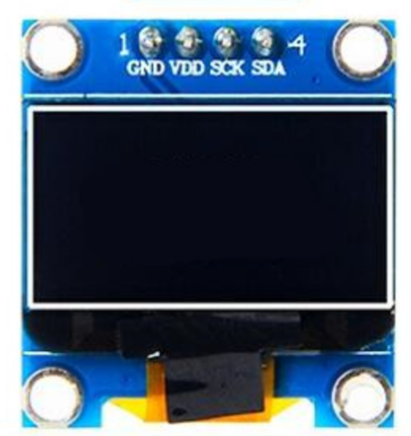Figure 4: SSD1306 OLED Display

The **SSD1306 OLED display** is a **128x64 pixel monochrome display** used to **show real-time sensor readings and system status**.

**Reasons for Choosing SSD1306**

* **Low power consumption** (suitable for embedded applications)
* **I2C communication** (only requires 2 pins, SDA & SCL)
* **Clear, high-contrast display** for easy readability

**Function in the Project**

* Displays **real-time temperature and humidity readings**
* Provides **visual confirmation** of recognized voice commands

## **2.5 SHT31 Temperature & Humidity Sensor – Sensor Data Acquisition**

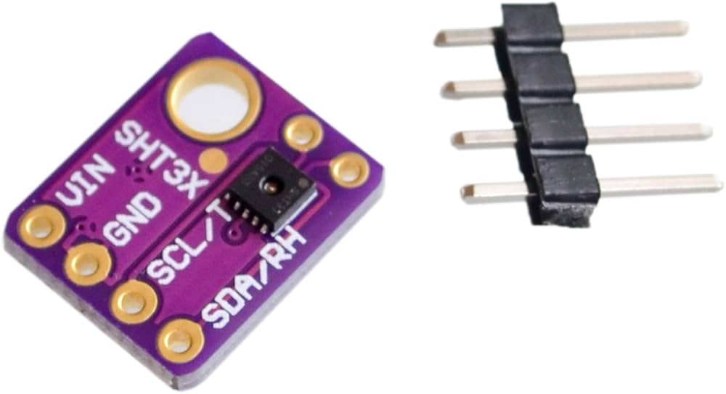Figure 5: SHT31

The **SHT31** is a highly accurate **temperature and humidity sensor** that communicates with the ESP32 over **I2C**.

**Reasons for Choosing SHT31**

* **High accuracy** (±0.3°C for temperature, ±2% for humidity)
* **Fast response time**
* **I2C communication** (easy interface with ESP32)

**Function in the Project**

* Measures **temperature and humidity** in real-time
* Sends data to the ESP32 for processing and display
* Enables the **audio response system** to announce current weather conditions

# 3 Setting up Development Environment

This guide will help students set up their iSEB **voice** recognition. We will use the VC-02 sound recognition module to recognize voice comand and play response using I2S speaker.

## 3.1 Block Diagram

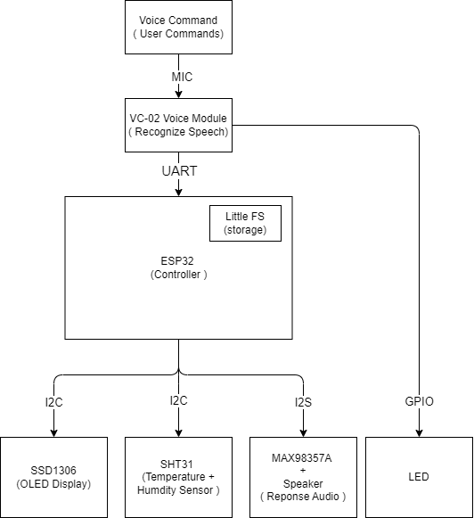

The system consists of the following primary components:

1. **ESP32 (Main Controller)** – Handles communication between all peripherals.
2. **VC-02 Voice Recognition Module** – Recognizes voice commands and sends them to the ESP32 via UART.
3. **SHT31 Temperature & Humidity Sensor** – Measures real-time environmental data and sends it to ESP32 via I2C.
4. **SSD1306 OLED Display** – Provides visual feedback on system status and sensor readings.
5. **MAX98357A I2S Audio Output + Speaker** – Plays voice responses based on recognized commands.
6. **LittleFS (ESP32 Internal Storage)** – Stores pre-recorded **WAV** files used for audio playback.

## 3.2 Schematic of the Infonique **voice** recognition

# 

## 3.3 Pinout connection

| Component | ESP32 Pin | Function |
| --- | --- | --- |
| VC-02 TX | GPIO16 | UART RX (Receive voice commands) |
| VC-02 RX | GPIO17 | UART TX (Send data if required) |
| I2S BCLK (MAX98357A) | GPIO25 | I2S Bit Clock |
| I2S LRC (MAX98357A) | GPIO26 | I2S Left-Right Clock |
| I2S DOUT (MAX98357A) | GPIO27 | I2S Data Output |
| SSD1306 OLED SDA | GPIO21 | I2C Data |
| SSD1306 OLED SCL | GPIO22 | I2C Clock |
| SHT31 SDA | GPIO21 | I2C Data (Shared with OLED) |
| SHT31 SCL | GPIO22 | I2C Clock (Shared with OLED) |

Table 1: ESP32 Pin Connection

## 3.4 Hardware compoenents

| Component | Description |
| --- | --- |
| **ESP32 Board** | The main microcontroller to process voice commands |
| **VC-02 Voice Recognition Module** | Recognizes voice commands and sends them to ESP32 |
| **VC-02 Programmer** | Used to upload firmware and custom voice commands to the VC-02 module. |
| **MAX98357A I2S Amplifier** | Plays sound responses |
| **Speaker (8Ω, 3W)** | Outputs the voice responses |
| **SSD1306 OLED Display** | Displays text output |
| **SHT31 Sensor** | Measures temperature & humidity |
| **Jumper Wires** | Connects components together |
| **Micro USB Cable** | Uploads code to ESP32 |
| Breadboard | Allows easy prototyping by connecting components without soldering. |

Table 2: Hardware Component

## 3.3 Development Environment

The guide will help student to set up their infonique sound recognitoin development environment .

Software Setup

### Step 1 : Install **Arduino IDE** to program the ESP32.

* **Download Arduino IDE** from: https://www.arduino.cc/en/software
* **Install it** on your computer.
* This prototype is built with Aduino IDE 2.3.2

**Step 2: Install ESP32 Board in Arduino IDE**

1. **Open Arduino IDE.**
2. **Go to File → Preferences.**
3. **Find "Additional Board Manager URLs" and paste:https://raw.githubusercontent.com/espressif/arduino-esp32/gh-pages/package_esp32_index.json**
4. **Click OK.**
5. **Go to Tools → Board → Boards Manager.**
6. **In the search bar, type ESP32.**
7. **Click Install for "ESP32 by Espressif Systems".**
8. **This prototype is using version 3.1.3.**

### **Step 3 : Install Required Libaries**

**In Arduino IDE, go to:  
Sketch → Include Library → Manage Libraries, then install:**

1. **Adafruit_SSD1306.h(tested with v2.5.10)** → For the OLED display
2. **Adafruit_GFX.h** (tested with V1.12.0) → Graphics library for OLED
3. **Adafruit_SHT31.h** (tested with v2.2.2)→ For temperature & humidity sensor
4. **AudioFileSourceLittleFS.h** (tested with ESP8266Audio v2.0.0 ) → To read audio files
5. **AudioGeneratorWAV.h** ( tested with ESP8266Audio v2.0.0 )→ To play WAV files
6. **AudioOutputI2S.h** ( tested with ESP8266Audio v2.0.0 ) → To output sound
7. **LittleFS.h,**Wire.h and HardwareSerial.h is standard ESP32 library.

### Step4: Configure LittleFS for WAV file storage.

LittleFS stores the **WAV files** on ESP32’s flash memory.

1. **Enable LittleFS in Arduino IDE**:
   * Go to **Tools** → **Partition Scheme** → **"Huge APP (NO OTA 2MB APP/2MB SPIFFS)"**.
   * This allocates more space for **LittleFS**.
2. **Upload WAV Files to ESP32**:
   * Place WAV files (hi.wav, temp.wav, etc.) in data/ inside your project folder.
   * Generetae the littlefs.img by calling the cmd
     + ""ADD UR PATH'\iSEB_SoundRecognition\Software\Tools\mklittlefs\mklittlefs.exe" -c data/ -p 256 -b 4096 -s 0x1E0000 littlefs.img
     + eg : "C:\iSEB_SoundRecognition\Software\Tools\mklittlefs\mklittlefs.exe" -c data/ -p 256 -b 4096 -s 0x1E0000 littlefs.img
   * Upload the littlefs.img by calling.
     + python -m esptool --chip esp32 --port “YOUR COMP PORT “ write_flash 0x210000 littlefs.img
     + eg: python -m esptool --chip esp32 --port COM6 write_flash 0x210000 littlefs.img

### Step 5 : Configure and upload binary to VC-02 voice recognition module

The details can refer to the link below:

### https://docs.ai-thinker.com/en/voice_module

The **VC-02** voice recognition module requires a firmware update or custom binary upload to work correctly. We can use the VC-02 usb programmer to program it with following connection:

* **VC-02 Module** → **VC-02 Programmer**
* **VC-02 Programmer** → **PC via USB**

The programmer has built-in connections, so no extra wiring is needed. **We can just upload the binary file with the following steps.**

* Open VC_EVB.exe
* Select **COM Port** (Check Device Manager for your USB adapter)
* Click **"Open COM"**
* Click **"Load Firmware"** and select the .bin file
* Click **"Start Upgrade"**
* Wait for the process to finish (takes ~1 min)
* Click **"Reset Module"** or manually press **RESET** on VC-02

### Step 6: Connecting the hardware

Use jumper wires to connect the components.

* Connect VC-02 ( voice module )

| VC-02 Pin | ESP32 |
| --- | --- |
| TX (Output) | GPIO **16** (RX) |
| RX (Input) | GPIO **17** (TX) |
| GND | GND |
| VCC | 3.3V |

* Connect MAX98537A ( Speaker Amplifier )

| MAX98357A Pin | ESP32 |
| --- | --- |
| BCLK (Bit Clock) | GPIO **25** |
| LRC (Word Select) | GPIO **26** |
| DIN (Data Input) | GPIO **27** |
| GND | GND |
| VIN | 5V |

* **Connect SSD1306 OLED Display**

| OLED Pin | Connect to ESP32 |
| --- | --- |
| SDA | GPIO **21** |
| SCL | GPIO **22** |
| GND | GND |
| VCC | 3.3V |

* **Connect SHT31 (Temperature & Humidity Sensor)**

| *SHT31 Pin* | *Connect to ESP32* |
| --- | --- |
| *SDA* | *GPIO* ***21*** |
| *SCL* | *GPIO* ***22*** |
| *GND* | *GND* |
| *VCC* | *3.3V* |

### Step 7 Run your firt voice command.

* The Upload code to esp32
* ESP32 will retrieve the reading from SHT31 and display at SSD1306 OLED display.
* VC-02 will detect the pretrained voice command and send uart communication to ESP32.
* ESP32 will decode the command and retreive the wav file from litttle FS and reply through MAX98537A